**Frequency domain modeling using MATLAB**

**Lab report #08**



Fall 2022

CSE-310L Control Systems

Submitted by: **Ashfaq Ahmad**

Registration No: **19PWCSE1795**

Class Section: **B**

“On my honor, as student of University of Engineering and Technology, I have neither given nor received unauthorized assistance on this academic work.”

Student Signature: ______________

Submitted to:

**Dr: Muniba Ashfaq**

**Dec** 24, 2022

**Department of Computer Systems Engineering**

**University of Engineering and Technology, Peshawar**

**Objective(s):**

* To know about residue function
* To know about ilaplace function

**Residue function:**

**Syntax:**

[r,p,k]=residue[b,a]

[b,a]=residue[r,p,k]

**Description:**

[r,p,k]=residue[b,a] finds the residues, poles, and direct term of a partial fraction expansion of ratio of two polynomials.

[b,a]=residue[r,p,k] converts the partial fraction expansion back to the ratio of two polynomials and returns the coefficients in b and a.

Simply residue is the inter-conversion of partial fraction expansion and ratio of two polynomials.

**ilaplace function:**

syntax:

f=ilaplace(F)

description:

ilaplace takes a system F in frequency domain and convert it to time domain f.

It is opposite to Laplace transform.

**Task01:**

Find the residues of the following function.

F(s)=2/(s+1)+(s+2)2

**Source code:**

clc

clear

close all

num=[2];

denum=[1,5,8,4];

[r,p,k]=residue(num,denum)

%r gives the values of veriables like A B C in partial fraction.

**Output:**

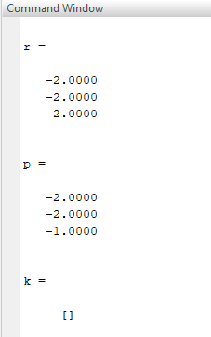

**Task02:**

Find the residues of the following function.

F(s)=3/s(s2+2s+5)

**Source code:**

clc

clear

close all

num=[3];

denum=[1,2,5,0];

[r,p,k]=residue(num,denum)

**Output:**

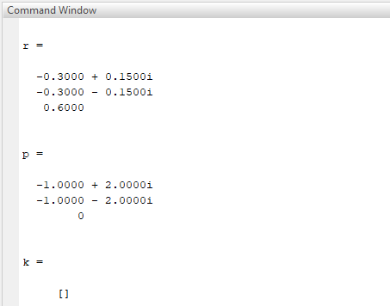

**Task03:**

Find the residues of the following function.

F(s)=5/(s+1)+(s+2)+(s+3)

**Source code:**

clc

clear

close all

num=[2];

denum=[1,6,11,6];

[r,p,k]=residue(num,denum)

Output:

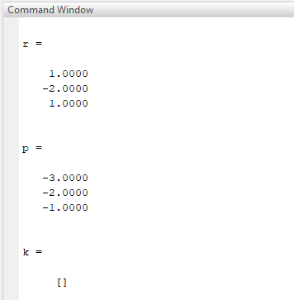

**Task04:**

Find the inverse impulse response of the following system using symbolic toolbox.

F(s)=1/s(s+2)

**Source code:**

clc

clear

close all

syms s;

c=1/(s*(s+2));

c=ilaplace(c)

pretty(c)

%inverse laplce transform convet system again to time domain from frequency

%domain.

**Output:**

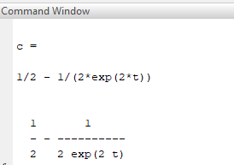

**Task05:**

Find the inverse impulse response of the following system using symbolic toolbox.

F(s)=2/(s+1)+(s+2)

**Source code:**

%find inverse laplace transform using symbolic toolbox.

clc

clear

close all

syms s;

c=2/(s+1)*(s+2)^2;

c=ilaplace(c)

pretty(c)

**Output:**

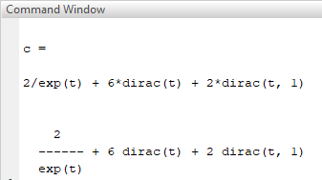

**Task06:**

Find the inverse impulse response of the following system using symbolic toolbox.

F(s)=3/s(s2+2s+5)

**Source code:**

%find inverse laplace transform using symbolic toolbox.

clc

clear

close all

syms s;

c=3/s*(s^2+2*s+5);

c=ilaplace(c)

pretty(c)

**Output:**

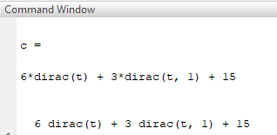

**Task07:**

Find the inverse impulse response of the following system using symbolic toolbox.

F(s)=5/(s+1)+(s+2)+(s+3)

**Source code:**

%find inverse laplace transform using symbolic toolbox.

clc

clear

close all

syms s;

c=2/(s+1)*(s+2)*(s+3);

c=ilaplace(c)

pretty(c)

**Output:**

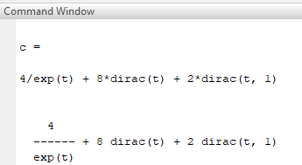

**Task08:**

Using MATLAB and symbolic toolbox to help you find the value of current.

(2s+2)+I1(s) -(2s+1)I2 (s) -I3(s) =V(s)

-(2s+1)+I1(s) +(9s+1)I2 (s) -4sI3(s) =0

-I1(s) - 4sI2 (s) + (4s+1+1/s)I3(s) =0

**Source code:**

%using matlab and symbolic toolbox to help you find the of the currents.

clc

clear all

close all

syms s I1 I2 I3 V

A=[(2*s+2), -(2*s+1), -1;

-(2*s+1), (9*s+1), -4*s;

-1, -4*s,(4*s+1+(1/s))];

B=[I1;I2;I3];

C=[V;0;0];

B=inv(A)*(C) % inversion method.

pretty(B)

**Output:**

